Personal Training Client Intake Form
Please fill in and save this form in Word, Google Docs or ODS.
The more information you provide, the better I will be able to assist you. You can use either the imperial or metric system to fill in this form. Just state which unit you used (e.g. cm, kg, lb, inch).

General
- Full legal name:
- Street and house number:
- Postal code:
- City:
- Country:
- Age:
- Height:
- Weight:
- Body fat percentage (plus estimation method):
- Years of training experience:

Strength
For the section below, please give your current maximum abilities in weight times reps, e.g. 250 lb x 6.
- Bench press:
- Squat (excluding body weight):
- Chin-up (excluding body weight):
- Overhead press:

What are your fitness goals?

How often in a week would you be prepared to train for maximal results?

What is your occupation?
You may be general here, e.g. student/manager/personal trainer/manual labor/doctor. The aim is to characterize your circadian rhythm, stress and activity level.

Please list any pathologies and injuries (disabilities, allergies, illnesses, syndromes, disorders etc.) you have or had:

Do you insist on any special diet (e.g. ketogenic, vegan)?

Do you plan to use any PEDs while working together? If so, please list them:

Lifestyle

Are there any times at which you are unable or unwilling to train? (This includes when you’re at work!) If so, please list them:

Activity level
Please mark one of the fields below or delete the rest.
- Sedentary (e.g. office job)
- Somewhat active (e.g. you walk your dog several times a day or you commute by bicycle)
- Active (e.g. full-time PT, literally on your feet most of the day)
- Very active (e.g. involved in manual labor)

Stress level
Please mark one of the fields below or delete the rest.
- Stress-free (e.g. on holiday)
- Only occasional/mild stress (e.g. student not during exam period)
- Average stress (e.g. full-time work with deadlines and commuting)
- High stress (e.g. very high-paced work environment with great responsibility)

How is your sleep rhythm and quality?

How much caffeine do you consume daily on average or on a typical work day?

Equipment

Do you have skinfold calipers or any other type of at-home body composition analysis tool? If so, which one(s)? Do you have access to a DEXA Scanning facility?

What are the lightest barbell weight plates you have access to?

What are the smallest weight increments between the sets of dumbbells you have access to?

Do you have access to…
- a squat cage or rack?
- a 45° hyperextension bench?
- a reverse hyper machine?
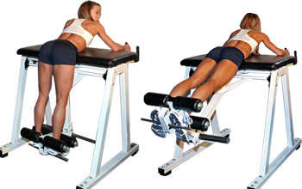
- a glute-ham raise?
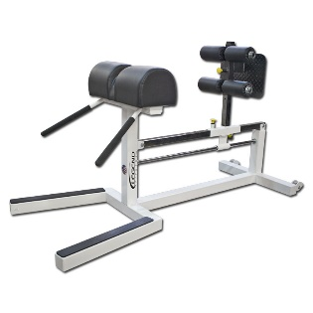
- a standing calf raise machine?
- a dip/chin-up belt?
- a leg curl machine and if so, is it seated, lying or standing?
- a pair of knee wraps?
- gymnastic rings?
- a TRX or similar suspension device?
- powerlifting bands (not the light home workout stuff)?
- powerlifting chains?
- a seated calf raise and if so, is it closed chain where you push your body up (see example image below) or different?
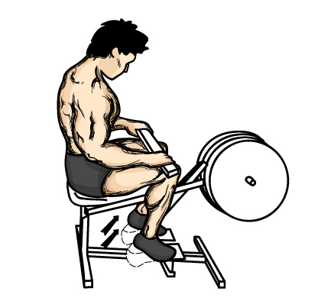

Does your available equipment differ from that in most gyms in any other way (e.g. you train in a Crossfit box or at home)?

Supplements
Please list all the supplements you are currently taking:

Genetics
- Wrist circumference (smallest point):
- Ankle circumference (smallest point):
- How much did you weigh before you started lifting and what was your height at that point?
- Were you heavy as a baby?
- Please attach a picture to this form in which the back of your right hand is clearly visible. Ideally, place your right hand on a flat surface with your fingers touching each other and then take a picture of it.

Current Program
Please describe or attach your current diet plan in detail:

Please describe or attach your current training program in detail:

Please return the filled in form to tailormadefitness13@gmail.com and attach at least two full-body pictures of yourself in clear lighting (no excessive shadows, & not your most flattering Facebook selfies). Preferably, include a back double-biceps & front relaxed pose.
*Legal Disclaimer: By returning this intake form, you declare that while Joe Flaherty is your personal trainer, all the substances you use are obtained & used in accordance with their governing laws & you forego all rights to hold Joe Flaherty liable for any damages caused in relation to following his advice as a trainer.

